Title (20 size)
(13 size) A Project Based Learning Report Submitted in partial fulfilment of the requirements for the award of the degree

of

Bachelor of Technology
in The Department of CSE
Embedded Systems Design And IOT-25EC2206E

Submitted by
2510030400- P Varshitha
2510030374-G Sri Harini
2510030278-E Varshitha
2510030178-Pranavi
Under the guidance of
DR. Chandrasekhar



Department of Electronics and Communication Engineering
Koneru Lakshmaiah Education Foundation, Aziz Nagar
Aziz Nagar – 500075
FEB - 2025.
Abstact

The Smart RFID Attendance System is an automated attendance management solution designed to overcome the limitations of traditional manual attendance systems, such as time consumption, human errors, inaccurate records, and lack of real-time monitoring. The proposed system uses Radio Frequency Identification (RFID) technology to identify students through unique RFID cards and automatically record their attendance with timestamps. An Arduino-based RFID reader captures the card identification number and communicates with the attendance database for student verification and record management.
To improve security and reduce the possibility of proxy attendance, the proposed system further integrates camera-based face verification with RFID identification. In this two-stage verification process, the student first scans the RFID card, followed by real-time face capture and verification. Attendance is recorded only when the RFID identity and detected face match successfully. The system stores verified attendance records in a centralized database and provides real-time monitoring through an administrative dashboard.
The proposed system offers a fast, contactless, reliable, and scalable approach for attendance management in schools, colleges, universities, and training institutions. The methodology also supports evaluation based on RFID reading accuracy, face verification correctness, identity matching, response time, proxy-attempt rejection, and database reliability. Overall, the integration of RFID and face verification provides a more secure and efficient attendance solution while reducing manual effort and improving the reliability of attendance records.

List of Figures

Figure 1.1 – Smart RFID Attendance System Overview
Figure 2.1 – Motivation and Problems in Traditional Attendance Systems
Figure 3.1 – System Architecture / Block Diagram
Figure 3.2 – RFID-Based Attendance Workflow
Figure 3.3 – Two-Stage Identity Verification Process
Figure 3.4 – RFID Card and RFID Reader
Figure 3.5 – Camera-Based Face Verification
Figure 3.6 – RFID and Face Matching Process
Figure 3.7 – Attendance Decision Flowchart
Figure 3.8 – Central Database and Real-Time Dashboard
Figure 4.1 – Hardware and Software Components
Figure 4.2 – Methodology and Technical Workflow
Figure 4.3 – Attendance Verification Test Cases
Figure 5.1 – Applications of the Smart Attendance System
Figure 5.2 – Advantages of the Proposed System
Figure 6.1 – Future Enhancements of the System

List of Tables

Table No. | Title of the Table
Table 1.1 | Problems in Traditional Attendance Systems
Table 2.1 | Project Objectives
Table 3.1 | Hardware Components Used in the System
Table 3.2 | Software Components Used in the System
Table 4.1 | RFID-Based Attendance Workflow
Table 4.2 | Face Verification and Identity Matching Process
Table 5.1 | Methodology Evaluation and Test Cases
Table 5.2 | Evaluation Parameters
Table 6.1 | Applications of the Smart RFID Attendance System
Table 6.2 | Advantages of the Proposed System
Table 7.1 | Current Development Status
Table 7.2 | Future Enhancements

Table of Contents

Introduction

- Methodology
- RFID card/tag is assigned to each student.
- RFID reader scans the student’s card.
- The microcontroller receives the RFID ID.
- The system identifies the student.
- Attendance is automatically recorded with date and time.
- The attendance data is stored in the database/system.
- The teacher/admin can view the attendance records.

2 Experiments
Experimental Setup
RFID Card Registration
Attendance Testing
Multiple Student Testing
Duplicate Attendance Test
Invalid Card Test.
Data Verification

3 Results

Successful RFID Detection.
Accurate Student Identification
Automatic Attendance Recording
Duplicate Prevention attendance.
Invalid Card Detection
Data Storage

INTRODUCTION
Attendance management is an essential activity in educational institutions, offices, organizations, and other professional environments. Maintaining accurate attendance records helps institutions monitor the regularity and participation of students or employees. Traditionally, attendance is recorded manually by calling names, signing attendance sheets, or maintaining registers. Although these methods are simple, they require considerable time and effort and may result in errors, loss of records, or inaccurate attendance information. With the development of modern technologies, automated attendance systems have become an effective solution for improving the speed, accuracy, and reliability of attendance management.
The Smart RFID Attendance Tracking System is an automated attendance management system developed using Radio Frequency Identification (RFID) technology. RFID is a wireless technology that allows objects to be identified using radio frequency signals. In this system, every student is provided with a unique RFID card or RFID tag. The RFID card contains a unique identification number that is associated with the student's details in the system. When the student places the RFID card near the RFID reader, the reader detects the card and obtains its unique identification number.
The captured RFID information is then processed by the microcontroller or processing unit. The system compares the received RFID number with the registered student information stored in the database. If the RFID card belongs to a registered student, the system identifies the student and automatically marks the attendance. The attendance record can contain important information such as student ID, student name, date, and time of attendance. This information can be stored digitally and accessed whenever required.
The main objective of the Smart RFID Attendance Tracking System is to reduce the manual effort involved in attendance management. In a traditional system, a teacher may need to spend several minutes taking attendance for an entire class. When the number of students is large, this process can consume valuable teaching time. By using RFID technology, attendance can be recorded within a short period because students only need to scan their RFID cards near the reader.
Another important advantage of the proposed system is improved accuracy. Manual attendance systems can be affected by human errors such as marking the wrong student, missing a student's attendance, or entering incorrect information. An automated RFID system reduces these errors because the student is identified using a unique RFID number. The system can automatically associate the RFID number with the correct student record.
The system can also help in preventing duplicate attendance entries. For example, if a student scans the same RFID card multiple times within the same attendance session, the system can check whether attendance has already been recorded for that student. If the attendance has already been marked, the system can prevent another duplicate entry. This improves the reliability and consistency of attendance records.
The Smart RFID Attendance Tracking System can also identify unauthorized or unregistered RFID cards. When an unknown card is scanned, the system can compare its RFID number with the registered database. If the number is not available in the database, the system can reject the attendance request and provide an appropriate notification. This feature helps ensure that only registered students can record attendance.
Digital attendance records also make it easier to manage and analyze attendance information. Instead of maintaining large numbers of physical attendance registers, records can be stored electronically. Digital storage makes it easier to search for a particular student's attendance, check attendance history, and prepare attendance reports. It can also reduce the possibility of physical records being damaged or lost.
The proposed system consists of several important components that work together. The RFID card acts as the identification device for each student. The RFID reader is responsible for detecting and reading the unique identification number from the card. A microcontroller or processing unit receives the RFID information and processes it according to the programmed instructions. A database or storage system maintains the student and attendance information. Depending on the implementation, a display, buzzer, or web-based interface may also be used to provide confirmation and display attendance information.
The working process of the system begins when a student approaches the RFID reader with the assigned RFID card. The RFID reader generates radio frequency signals and detects the RFID card. The unique identification number stored in the card is transmitted to the reader. The reader sends this information to the microcontroller or processing unit. The system then checks the received identification number against the registered student database.
If the RFID number is valid, the corresponding student's details are retrieved from the database. The system records the student's attendance along with the current date and time. A confirmation message may be displayed to indicate that the attendance has been successfully recorded. If the card has already been used for attendance during the same session, the system can prevent duplicate attendance. If the RFID card is not registered, the system can display an invalid-card or unauthorized-card message.
RFID-based attendance systems provide several benefits compared with conventional manual methods. They can reduce attendance-taking time, minimize human errors, improve data organization, and provide quick access to attendance records. The technology is also relatively simple to operate because students only need to place their RFID cards near the reader. This makes the system convenient for both students and teachers.
The system can be implemented in different environments. In schools and colleges, RFID cards can be assigned to students for daily attendance. In offices, RFID cards can be used to record employee entry and exit times. Training institutes can use the system to monitor participant attendance. The same basic concept can also be adapted for laboratories, libraries, hostels, and other areas where identification and attendance tracking are required.
The development of this project also demonstrates the practical application of embedded systems, RFID technology, database management, and automated data processing. It provides an opportunity to integrate hardware and software components to create a useful real-world application. The project focuses on making the attendance process more efficient while maintaining reliable and organized records.
In addition to improving the attendance process, the system can provide a foundation for future improvements. For example, the system can be extended with a web-based dashboard where teachers or administrators can view attendance records in real time. Reports can be generated automatically based on dates, classes, or individual students. Notifications can also be added to inform teachers or administrators about attendance-related events.
tabase.
METHODOLOGY
The methodology describes the steps followed to develop the Smart RFID Attendance Tracking System. The system uses RFID technology to identify students and automatically record their attendance.
Proposed Methodology
Each student is provided with a unique RFID card. The card is registered with the student's details in the system. When the student places the card near the RFID reader, the reader detects the unique RFID number.
The microcontroller receives the RFID number and checks it with the registered student information. If the card is valid, the system records the student's attendance along with the date and time. If the card is already used, duplicate attendance is prevented.
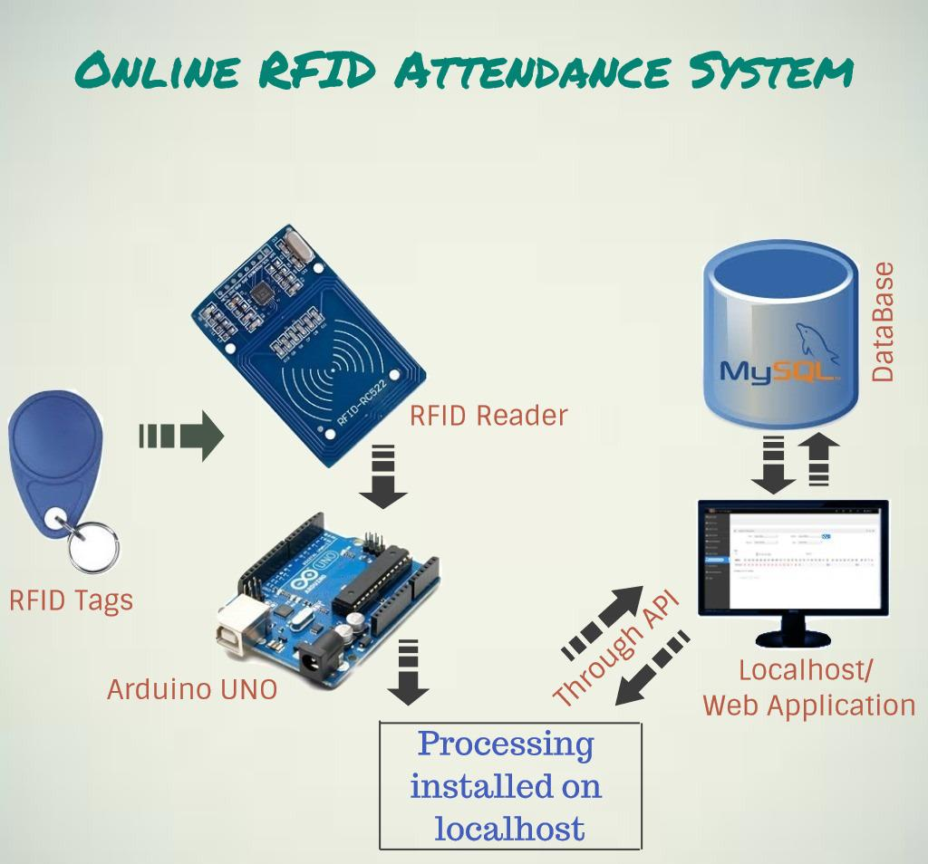

Working Procedure
The system works through the following steps:
- Student scans the RFID card.
- RFID reader reads the unique card ID.
- Microcontroller receives and processes the ID.
- The system checks the student details.
- Valid students are marked present.
- Date and time are recorded.
- Duplicate or invalid cards are rejected.
- Attendance data is stored for future use.
Database Management
The system stores student and attendance information digitally. The records include Student ID, Student Name, RFID ID, Date, Time, and Attendance Status
Testing
The developed system is tested using registered and unregistered RFID cards. Multiple students are tested to verify correct identification and attendance recording. The same card is scanned twice to check duplicate prevention, and an unregistered card is scanned to verify invalid-card detection.
Summary
The proposed methodology combines RFID technology, a microcontroller, and digital data storage to automate attendance. The system reduces manual work, saves time, minimizes errors, and provides an efficient method for attendance tracking.

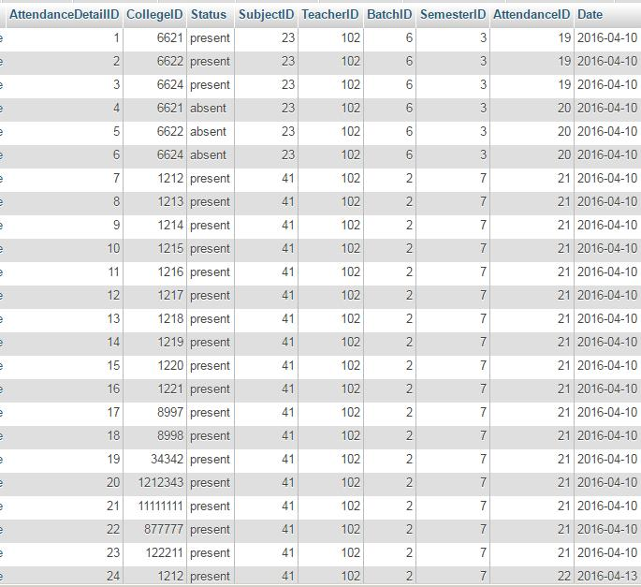

Experiment
The Smart RFID Attendance Tracking System was tested using an RFID card, RFID reader, microcontroller, display, and attendance database. The RFID card was scanned near the reader, and the unique card ID was sent to the microcontroller. The system verified the ID and recorded the student's attendance with the date and time.
Experimental Steps:
- Connect the RFID reader to the microcontroller.
- Register the RFID cards with student details.
- Scan an RFID card near the reader.
- Verify the detected student ID.
- Record attendance with date and time.
- Display the attendance status.
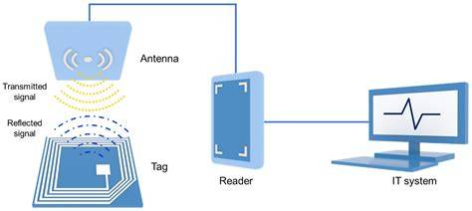

- Experimental Procedure
- 7.2 Experimental Steps
- The experiment was carried out to test the working of the Smart RFID Attendance Tracking System. The following steps were performed:
- Connect the Components:
Connect the RFID reader, microcontroller, LCD display, buzzer, and power supply according to the circuit design.
- Register Student Cards:
Assign a unique RFID card to each student and store the card ID along with the student's details.
- Power ON the System:
Switch on the system and allow the microcontroller to initialize all the connected components.
- Scan the RFID Card:
Place the student's RFID card near the RFID reader. The reader detects the unique identification number of the card.
- Verify the Card ID:
The microcontroller receives the card ID and compares it with the registered student information.
- Record Attendance:
If the card is valid, the system records the student's attendance along with the date and time.
- Display the Result:
The student's attendance status is displayed on the LCD or connected display. A buzzer may provide confirmation of successful scanning.
- Test Invalid Cards:
Scan an unregistered RFID card to verify that the system rejects the card and does not record attendance.
- Check Attendance Records:
Verify the stored attendance details to ensure that the correct student information and attendance time have been recorded.
- Repeat the Experiment:
Repeat the scanning process with different registered cards to verify the reliability and proper functioning of the system.

Experimental Observation
Test | RFID Card | System Response | Attendance
Test 1 | Registered Card | Student identified | Recorded
Test 2 | Registered Card | Student identified | Recorded
Test 3 | Registered Card | Student identified | Recorded
Test 4 | Unregistered Card | Card rejected | Not recorded
. RESULTS AND DISCUSSION
The Smart RFID Attendance Tracking System was successfully tested using RFID cards and an RFID reader. During the experiment, the system detected the unique identification number of registered RFID cards and verified the student information through the microcontroller.
When a valid RFID card was scanned, the system successfully identified the student and recorded the attendance with the corresponding date and time. The attendance status was displayed on the connected display. An unregistered RFID card was also tested, and the system rejected the card without recording attendance.
The experimental results show that the proposed system provides a fast, simple, and reliable method for recording student attendance. It reduces manual work and minimizes errors that may occur during traditional attendance marking.

Observed Results:
Test | Card Status | Result
1 | Registered | Attendance recorded
2 | Registered | Attendance recorded
3 | Registered | Attendance recorded
4 | Unregistered | Attendance rejected
Figure 8.1: RFID Attendance System Output
Insert a small image of the RFID reader/card and attendance display here.
- 9. CONCLUSION
The Smart RFID Attendance Tracking System successfully automates the process of student attendance using RFID technology. The system identifies students through their unique RFID cards and records attendance automatically.
The experiment demonstrated that the system is easy to use, saves time, reduces manual errors, and provides accurate attendance records. Therefore, the proposed system can be
REFERENCES
- Klaus Finkenzeller, RFID Handbook: Fundamentals and Applications in Contactless Smart Cards, Radio Frequency Identification and Near-Field Communication, Wiley.
- Arduino, Arduino Documentation and Technical Resources, Arduino.
- NXP Semiconductors, MFRC522 RFID Reader/IC Datasheet, NXP Semiconductors.
- M. Ayoub Khan, S. M. Khan, and M. K. Kumar, “RFID Based Attendance System,” International Journal of Engineering Research and Applications.
- M. A. Hannan et al., “RFID Based Automated Attendance System,” International Journal of Computer Applications.
- National Instruments, Introduction to RFID Technology and Applications, Technical Resources.
- Arduino, Arduino Uno Rev3 Technical Specifications, Arduino Documentation.

